Materials 1 Lab

# Tensile Tests of Materials

# Objectives:

1. Experimentally determine the elastic limit (or yield stress) and the ultimate tensile strength (UTS) of metallic and polymeric materials.
2. Consider the performance of these materials relative to their weight and cost.

# Introduction

One of the most basic material characterisation tests is the *uniaxial tensile test*. In a tensile test, load is applied to the specimen by gripping both ends and forcing them a greater distance apart. The current experiment allows you to investigate for yourselves the tensile behaviour of different engineering materials and compare the results.

The load-extension behaviour of materials was discussed in ***lectures***. The *engineering stress* σ is given by the *applied force* *F* divided by the *original cross-sectional area* *A*0, *i.e.*

|  |  |
| --- | --- |
|  | *(1)* |

Moreover, the *engineering strain ε* is given by the difference between the *current gauge length* *L* and the *original gauge length* *L*0 divided by the original gauge length, *i.e.*

|  |  |
| --- | --- |
| $$ε =\frac{(L-L_{0})}{L_{0}}= \frac{∆L}{L_{0}}$$ | *(2)* |

NOTE: This lab will focus on engineering stresses and strains (eqn 1 & 2). The concept of true stresses and strains will be discussed in the lectures.

The most common sets of units used in material testing are shown in Table 1. However, throughout your degree you will only use the metric system, primarily SI units. In the Structures and Materials 1 unit however, you can use millimetres (mm) and mega-Pascals (MPa) when it is more convenient.

Table 1: Common units used in materials testing.

|  |  |  |  |  |  |  |
| --- | --- | --- | --- | --- | --- | --- |
| System | Length | Mass | Force | Time | Area | Stress or pressure |
| Metric (SI) | m | kg | N | s | m2 | Pa (N·m-2) |
| Metric (mm) | mm | kg | N | s | mm2 | MPa (N·mm-2) |
| Imperial | in | lb | lbf | s | in2 | psi (lbf·in-2) |

The results of a *displacement-controlled* tensile test on a *ductile* material are shown schematically in Figure 1. At first the specimen deforms *elastically* (*i.e.* *reversibly*), so it would return to its original length if the load were removed at this stage. If the applied strain is increased (via an increasing *cross-head displacement*) we will eventually overcome the *yield strength* of the material, and the specimen will then deform *plastically* (*i.e.* *irreversibly*); if the load is removed at this stage the specimen will show only partial elastic recovery and will not go back to its original shape. If loading continues further, we will eventually reach the ultimate tensile strength (UTS) of the material, after which the load will start decreasing as *necking* takes place, *i.e.* the specimen width (or diameter) starts to decrease at a point along the gauge length due to ‘strain localisation’. For ductile metals, failure (or rupture) can occur shortly after necking, but for some polymers the necking phenomenon can continue to develop to very high elongations.

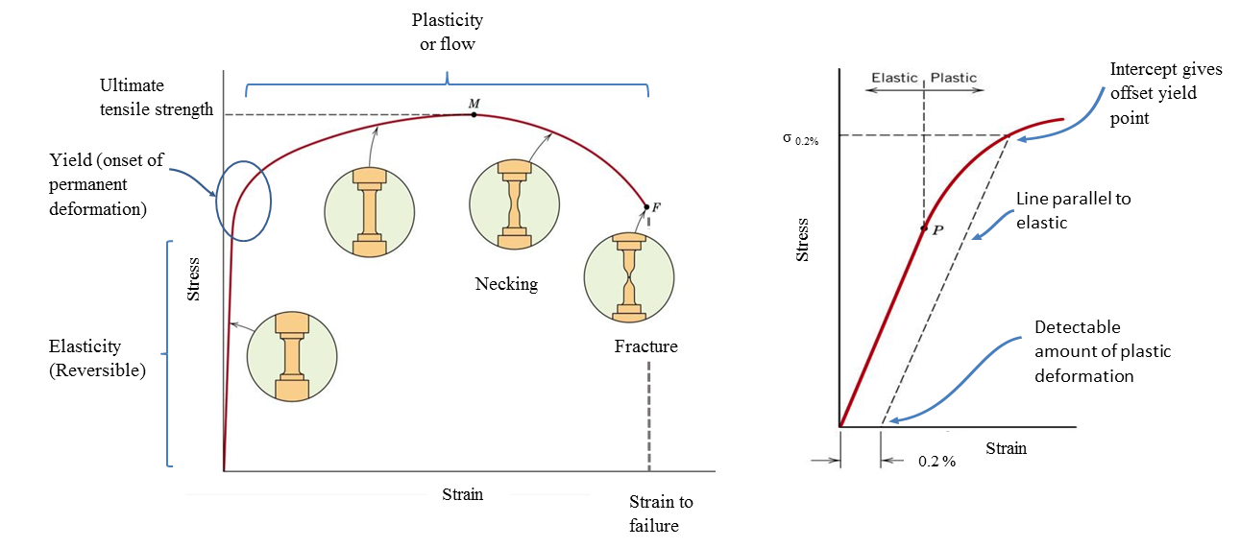

The following parameters can be derived from a tensile stress-strain curve:

* **Young’s modulus, *E***: This is the ‘gradient’ of the elastic portion of the stress-strain curve.
* **Yield strength, σ y:** This is the stress at the onset of plastic flow. This is sometimes difficult to determine from experiments, and in this case the concept of *proof stress* below is commonly used.
* **0.2% proof stress, σ 0.2%:** These are the stresses for permanent strains of 0.1% and 0.2%, respectively, as shown in Figure 2. Useful for characterising the yield of materials with a gradual transition between elastic and plastic behaviour.
* **Ultimate Tensile strength, σ UTS:** Also called the ultimate tensile strength (UTS), is the stress value at the onset of necking. This is usually the maximum value of stress observed in *engineering* stress-strain curves.
* **Strain at failure (elongation at break), *ε* f:** This is usually determined by putting the broken specimen back together, measuring the length of the assembled pieces and applying equation (2).

It should be noted that *brittle* materials such as ceramics and some composites may not show any plastic deformation before rupture or failure.

# Materials

1. 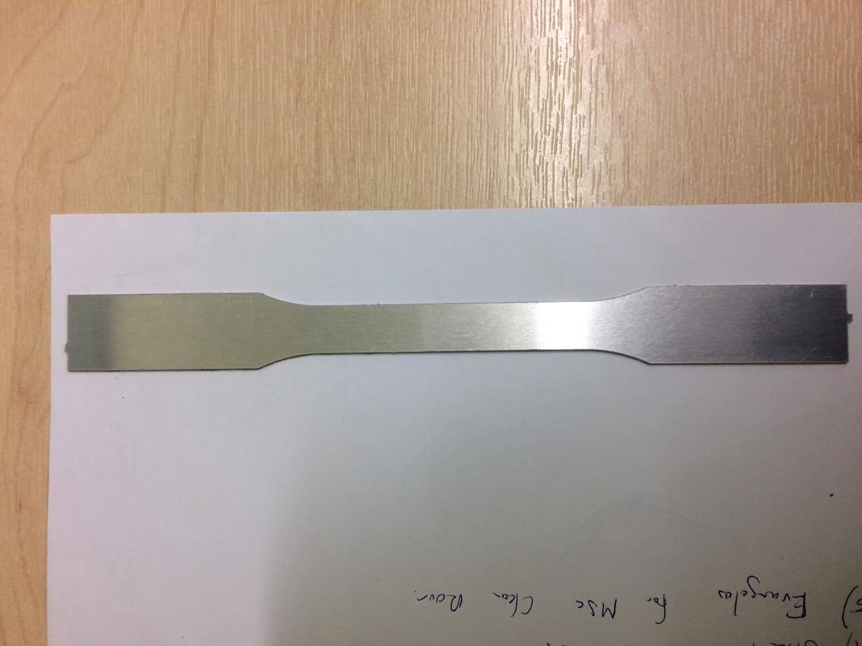**Aluminium alloy 6082-T6:** This is a high strength wrought alloy that has been age hardened. Aluminium alloys like this are often used in aerospace applications due to their high specific stiffness and strength.
2. 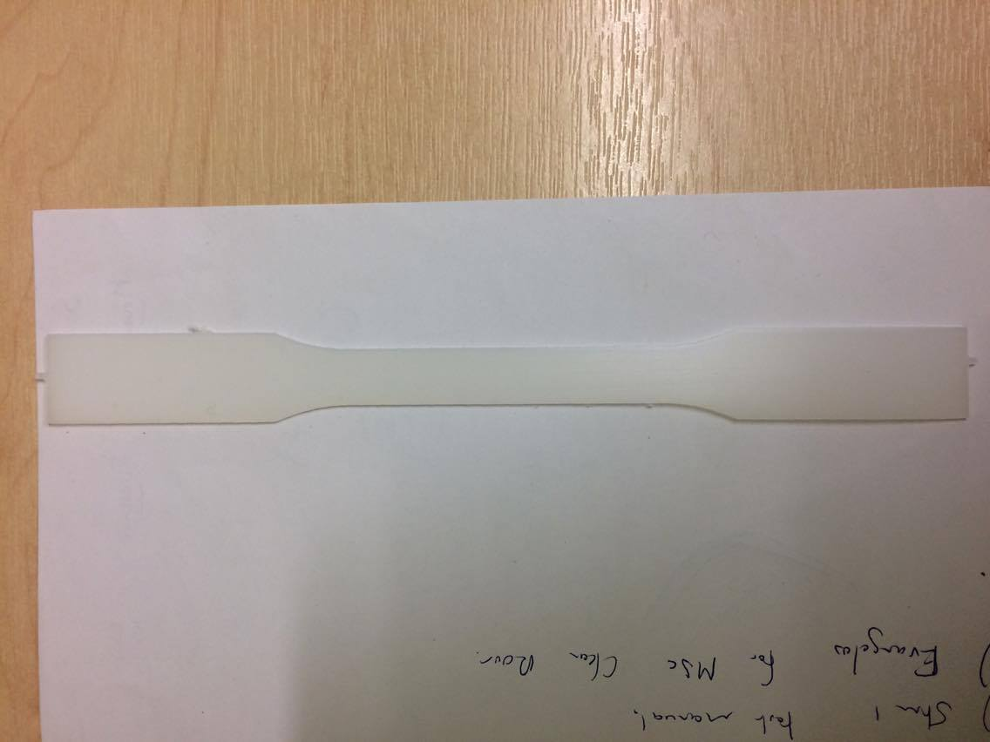**High density polyethylene (HDPE):** This thermoplastic polymer has a higher degree of crystallinity than low density polyethylene (LDPE), resulting in improved strength and stiffness. The improved mechanical properties, coupled with chemical inertness and resistance to permeation, make this type of polymer ideal for a variety of household applications including: disposable milk bottles, disposable shopping bags, chopping boards, *etc*.
3. 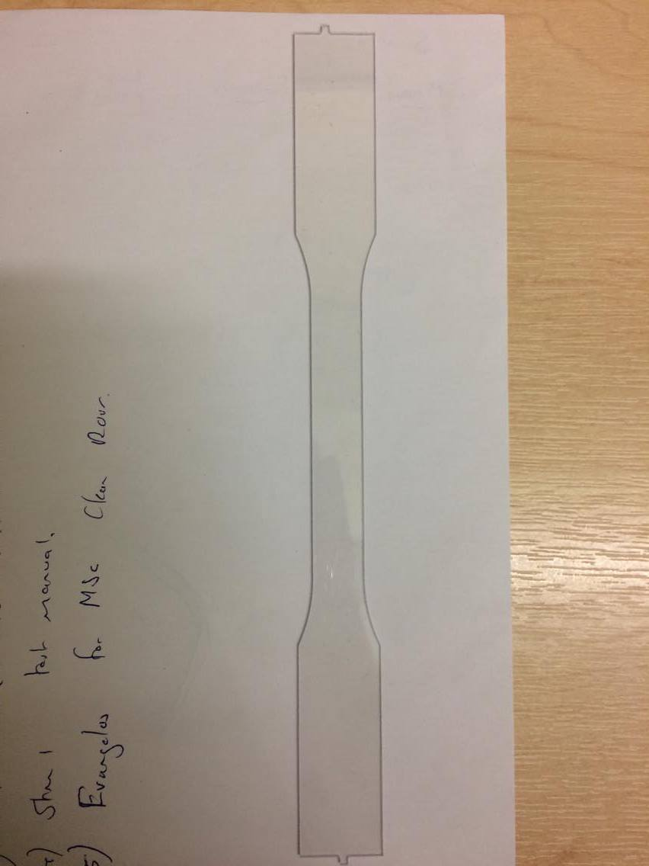**Poly-methyl-methacrylate (PMMA):** This isknown by the brand names Perspex®, Plexiglass® and the general term ‘acrylic’, PMMA it as a vitreous (amorphous) thermoplastic widely used in applications requiring optical transparency – *e.g.* as a replacement for mineral glass in windows, mirrors etc. Its optical properties are not as good as those of polycarbonate (used in spectacle lenses, CD/DVD/Blu-ray discs etc.) and the material is also quite brittle, but it is relatively cheap – hence its popularity.

# Procedure

Safety warning: Metal and polymer specimens are tested to failure. When they break, strain energy is released suddenly, which may cause pieces to fly off and cause injury to eyes. Ensure the safety guard is in place before the start of every test.

1. The detailed description of using the test machine is given in the **Tensile testing manual**.
2. The test will be conducted for three materials as specified before.
3. The raw data file containing the [Force], [Tensile Stress] and [Tensile Strain] measurements for each of the specimen is used along with given excel template.

# Results and Discussion

## Extracting basic tensile properties

* From your average width and thickness measurements, calculate the specimen cross-sectional area, *A*0.
* The excel template uses equations (1) and (2) above to convert the force-displacement data recorded by the machine into engineering stress-strain data. Calculate:
  + The yield strength (0.2% Proof stress)
  + Ultimate Tensile strength, σ UTS and Young’s modulus, *E* and elongation at Break

|  |  |  |  |  |
| --- | --- | --- | --- | --- |
| **Material** | **Yield strength(MPa)** | **Elongation at break**  **(%)** | **UTS, σ UTS**  **(MPa)** | **Young’s modulus, *E* (GPa)** |
| Aluminium alloy 6082-T6 |  |  |  |  |
| HDPE |  |  |  |  |
| PMMA |  |  |  |  |

## Comparing specific properties

A common objective in the design of aerospace structures is minimisation of the so-called ‘empty weight’ of the vehicle. The *specific properties* of the available materials are compared in order to facilitate material selection. The specific properties are the mechanical properties divided by their mass density. Table 2 shows the approximate mass densities of the materials tested in this lab. Using those values, and the results of your tensile tests, calculate:

* The specific modulus, *i.e.* the Young’s modulus divided by the density.
* The specific yield strength, *i.e.* the proof stress divided by the density.
* Table 2: Mass densities of the various materials tested in tension.

|  |  |  |  |
| --- | --- | --- | --- |
| **Material** | **Mass density (g·cm-3)** | **Specific yield strength**  **(kNm/kg)** | **Specific tensile modulus**  **(MNm/kg)** |
| Aluminium alloy 6082-T6 | 2.70 |  |  |
| HDPE | 1.10 |  |  |
| PMMA | 1.2 |  |  |

Another important factor in material selection is cost. Table 3 shows the relative cost of each material tested in this lab.

Table 3: Approximate costs for the various materials tested in tension.

|  |  |
| --- | --- |
| **Material** | **Relative cost [£·kg-1]** |
| Aluminium alloy 6082-T6 | 6.5 |
| HDPE | 2.5 |
| PMMA | 3.0 |

Based on the information above and the results of your tests, justify your choice of material for the following applications:

* The main spar of an Unmanned Aerial Vehicle (UAV) with a 2m wingspan, which is subjected to manoeuvre loads and the odd rough landing. Only ten aircraft are to be built, and they must operate without major issues for thousands of flight hours.
* The folding tray table in an economy class seat of a single-aisle jet airliner.